Reproducible Color Gamut of H&E-stained Images in the sRGB Color Space
Wei-Chung Cheng¹*

V2
For Journal of Pathology Informatics (http://www.jpathinformatics.org), Research Article

* Correspondence: Wei-Chung.Cheng@fda.hhs.gov
¹ Office of Science and Engineering Laboratories, Center for Devices and Radiological Health, US Food and Drug Administration, Silver Spring, Maryland, USA

Abstract

A whole-slide imaging (WSI) system is a digital color imaging system used in digital pathology with the potential to substitute the conventional light microscopes. A WSI system digitalizes a glass slide by converting the optical image to digital data with a scanner and then converting the digital data back to the optical image with a display. During the digital-to-optical or optical-to-digital conversion, a color space is required to define the mapping between the digital domain and the optical domain so that the numerical data of each color pixel can be interpreted meaningfully. Unfortunately, many current WSI products do not specify the designated color space clearly, which leaves the user using the universally default color space, sRGB. sRGB is a legacy color space that has a limited color gamut, which is known to be unable to reproduce all color shades present in histology slides. In this work, experiments were conducted to quantitatively investigate the limitation of the sRGB color space used in WSI systems. Eight hematoxylin and eosin (H&E) stained tissue samples, including human bladder, brain, breast, colon, kidney, liver, lung, and uterus, were measured with a multispectral imaging system to obtain the true colors on the pixel level. The measured color truth of each pixel was converted into the standard CIELAB color space to test whether it is within the color gamut of the sRGB color space. Experiment results show that all the eight images have a portion of pixels outside the sRGB color gamut. In the worse-case scenario, the bladder sample, about 35% of the image exceeded the sRGB color gamut. The results suggest that the sRGB color space is inadequate for a WSI scanner to encoding H&E-stained whole-slide images, and an sRGB display may have insufficient color gamut for displaying H&E-stained histology images.

Keywords: Color gamut, color space, color medical imaging, digital pathology, whole-slide imaging, hematoxylin and eosin stain, sRGB, color management

Background

A whole-slide imaging system is essentially a color imaging device comprising two cascaded subsystems for image acquisition and image display. The image acquisition subsystem includes the scanner, scan control software, and computer hardware. The scanner converts the optical signals of the glass slide into pixel data from the optical domain to the digital domain under the commands of the scan control software operated by the lab technician. The scan control software is also responsible for processing the large amount of pixel data that demands powerful computing, colossal storage, and fast networking capabilities. The image display subsystem includes the display, image review software, and the computer environment. The display converts the pixel data from the digital domain back to the optical domain. The pixel data needs to be uncompressed, decoded, and rendered by the image review software. The computer environment is required to execute the image review software and drive the display to show the final image to the pathologist user. Between the image acquisition subsystem and the image display subsystem, which may come from different manufacturers, the communication relies on the WSI file, which is created based on a mutually recognized file format. The image acquisition subsystem and the image display subsystem can be located in different institutes to utilize the benefits of telemedicine via remotely accessing to the image files, which can be stored on a different site.
Display

Scanner

Software -
Scan
Software -
Review
Computer -
Workstation
Computer -
Server
Glass Slide
Human Reader
WSI
image file
Digital Domain
Optical Domain
sRGB
DisplayPort
Windows
Figure 1: How WSI changes the workflow in pathology. Conventionally, a glass slide was viewed by the human reader via a light microscope, which processed the image in the optical domain (cyan shaded) entirely and did not impose color performance issues. In digital pathology, a WSI system uses a scanner to convert the optical image into the digital domain (yellow shaded) with computer hardware and software components. The image data is stored in a specific file format and transmitted to the review workstation. The review workstation decodes the digital data and reproduces the image in the optical domain with a display. The color spaces used by the scanner, file format, and display determine whether the histological image can be faithfully reproduced.

[color space why]
[survey]
Studies that compare medical grade and consumer grade displays started as early as a decade ago. An early study conducted at University of Arizona compared the eye-tracked diagnostic performance of reading digital radiography chest images with two monitors including consumer grade (Dell 2405) and medical grade (Barco Coronis MDCC-3120-DL) displays [2008]. Another study conducted at Emory University compared the diagnostic performance of reading CT images with three monitors including laptop (Vostro 3750, Dell), consumer grade (Dell UltraSharp U2711), and medical grade (NEC MD213MG) displays [2014]. A recent study conducted at University Hospital Cologne, Germany compared the diagnostic performance of reading digital radiography bone images with three displays including consumer grade (Dell UltraSharp U3014) and medical grade (Eizo RadiForce RX440 and RX650) displays [2017]. In these studies, all the medical images were monochrome and color consumer grade displays were used to read them. In these papers, "display calibration" strictly means the conformation of the DICOM GSDF standard. The important specifications of monochrome displays such as Lmin, Lmax, contrast, pixel count, and pixel size were provided in the papers. Although the primary color information was not described or tested, it is adequate since the studies were based on monochrome images. However, when the same study design was transplanted to WSI, the missing information became inadequate.
for example,
A study conducted at University of Pittsburgh Medical Center compared the diagnostic performance of reading surgical pathology and cytopathology slides with four displays including laptop (Dell Latitude D620), consumer-grade (Dell E248WFPb), professional-grade (Eizo CG245W), and medical-grade (Barco MDCC-6130) displays. Neither the gamma nor the primary information was included in the paper [2013].
A study conducted at University of Nebraska Medical Center in 2015 claimed to use a 16-bit grayscale monitor to generate 65 thousand shades of gray. Such a technical description was puzzling because the display technology of 16-bit grayscale is not even ready as today [2015].
A study conducted at Mayo Clinic compared the reader performance with a medical-grade monitor versus a non-medical display and suggested "noncalibrated displays could be considered for fine assessment tasks." Although nine board-certified pathologists participated to provide valuable reader responses, the study cannot be reproduced because of lack of technical information. On one hand, the medical-grade display (Barco Coronis Fusion 6MP LED display without an identifiable model number) was calibrated to the DICOM GSDF standard, but it is unclear what color space was used to calibrate the primary colors because the DICOM GSDF standard is for monochrome displays only. On the other hand, the so-called "non-calibrated" commercial off-the-shelf display (Dell UltraSharp U3014) was the top-of-line model that supported both the sRGB and the Adobe RGB color spaces, but it was unclear which one was used in the study. This type of displays supporting multiple standard color spaces are usually considered professional grade because a flat panel with higher bit-depth (frequently 10 bits or more per channel) and internal circuitry for calibration look-up tables are required. Thus, it may be inaccurate to call such a display non-calibrated. [2018]
An earlier, similar study conducted at the same institute described in an abstract used four displays including laptop (IBM ThinkPad 14.1), consumer-grade (HP ZR24w), small medical-grade (Eizo SX2462W), and large medical-grade (Barco Fusion 6MP 30 inch without identifiable model number) displays. No additional display information was included in the abstract due to the length limitation. [2018]

In digital color imaging, it is well known that a color pixel coming from a camera or going to a display consists of three components, red, green, and blue (RGB), which are represented as three numerals. In the computer graphics literature, frequently a triple in the format of (r,g,b) is used to specify a color without explicitly referencing a color space. Such a numerical representation of colors might be sufficient for processing color image in the digital domain, but not for accurate color acquisition or reproduction that requires a well-defined relationship linking the digital data with the actual color stimulus in the real world.
The deficiency can be explained by the analogy of describing three-dimensional objects. For instance, describing two rectangular blocks by only "3x3x3" and "4x5x6" help us conceptually comprehend their relative shapes (a cube vs a rectangular block) and sizes (the former is smaller than the latter). However, it is not sufficient to reproduce the two blocks accurately or to compare the two blocks objectively until the exact unit information is revealed. For example, a block of 3 in x 3 in x 3 in is larger than one of 4 cm x 4 cm x 4 cm because the units are different. Also, a block of 3 in x 3 in x 3 in is of a completely different shape from a block of 3 cm x 3 in x 3 ft because the units do not follow the same standard. In colorimetry, the definitions of the (r,g,b) triple is as critical as the width, length, and depth of a rectangular block whenever the subject needs to be referenced in the real world. A well-defined color space is crafted for such purposes.

The relationship between the digital data and actual stimulus is established upon two factors: the gamma curve and the primary colors.
The first factor, the gamma curve, is important for not only color but also monochrome images. The digital image data used in imaging processing usually refers to the perceptual domain. For example, a monochrome pixel of 100 is perceived as twice bright as a pixel of 50. However, when reproducing the pixels on a display, the required luminance is greater than twice because the human visual system does not perceive luminance linearly.
The second factor, the RGB primary colors, is absent in monochrome imaging. Each primary needs to be defined colorimetrically in a standard, absolute color space such as the CIEXYZ. CIEXYZ is a three-dimensional space constitutes by the tristimulus values CIE X, Y, and Z. Conventionally the tristimulus (capitalized X, Y, and Z) is decomposed into the two-dimensional chromaticity component (lowercased x and y) and the one-dimensional luminance component (capitalized Y). The tutorial of colorimetry can be found in .
A well-defined color space includes both the gamma curve and the primary colors.
Compared with the other digital revolution for the other imaging modalities, the color performance for WSI has been overlooked. In radiology, a successful modality in medical imaging, the X-ray film has been replaced by digital X-ray detectors. Color is not considered in monochrome imaging. Photographic scanner has been widely used for scanning photographic film, photos, documents, which are media with limited color gamut. The TV has been advanced from digital from broadcasting, display, in TV engineering, the color is not important becayuse fedality not .
The interpretation is a color space, which is a major part of colorimetry. Using the (r,g,b) without referencing the color space is analogous to using a number to express a distance without quoting a length unit. The numerals provide some relative information for comparing two distances but insufficient for accurate estimation.
colorimetry has been used intensively in some industries such as paint,
Consumer imaging devices such as cameras and displays are driven by consumer for entertainment applications, in which does not care about inaccurate color reproduction is not important.
in other words, in most cases, the color is unmanaged, meaning that the interpretation of (r,g,b) is undefined.
undefined color is acceptable because the human color visual system is not precise enough to tell the absolute difference compared with instruments.
color spaces are used to define the mapping between the digital domain and the colorimetric domain.
because of the dependency, the color space needs to be realistic of the underlying color imaging device.
the reproducible color gamut of a color imaging device is limited by the display technologies
the color gamut is getting wider, and new color spaces are required

many new color spaces is

two aspects: intended and actual
Besides the color space designated by the imaging device, another concern is whether the imaging device comply with the so-claimed color space. For example, most consumer-grade displays are sRGB. However, in our experience of characterizing color displays, only very few professional-grade displays could achieve the color gamut of the sRGB.

In the areas of imaging processing and computer graphics, tons of algorithms have been developed for processing colors. Most algorithms are operating in the digital domain. The processing most of them do not refer to the final display or the camera inputs, which are culturally considered as different disciplines.

sRGB based evaluation:
Shrestha 2014
Bautista JDI 2015

Methods

Materials
Eight formalin fixed paraffin embedded (FFPE), hematoxylin-and-eosin stained tissue microarray (TMA) slides (US Biomax, Inc., MD, USA) were used in this study. The TMA slides included human bladder, brain, breast, colon, kidney, liver, lung, and uterus. Each TMA slide contains dozens of tissue samples including both normal and malignant cases. One normal sample from each TMA slide was used in this study. A region of interest (ROI) was chosen for each sample to include important textbook features. The images of the ROIs are shown in Figure 2.
(a) Bladder | (b) Brain | (c) Breast | (d) Colon
(e) Kidney | (f) Liver | (g) Lung | (h) Uterus
Figure 2: The eight ROIs used in this study: (a) bladder, (b) brain, (c) breast, (d) colon, (e) kidney, (f) liver, (g) lung, and (h) uterus.

Apparatus
A multispectral imaging system was used to measure the color truth of the glass slides. The multispectral imaging system was implemented by retrofitting a conventional light microscope. It comprised four components –– microscope, tunable light source, camera sensor, and control software. The hub of the multispectral image system was an upright light microscope (AxioPhot 2, Carl Zeiss Microscopy, NY, USA) in bright-field mode with a 10X objective (Carl Zeiss A-Plan 10X/0.25 Ph1). A motorized XY-stage (MAC 6000, Ludl Electronic Products Ltd., Hawthorne, NY, USA) translationally moved the glass slide under the objective to locate the desired region of interest. The glass slide was illuminated by, in lieu of a conventional tungsten halogen lamp, a tunable light source (OL490 Agile Light Source, Gooch and Housego, TX, USA), which will be described below. On the detector side, a scientific monochrome CCD camera (Grasshopper3 9.1 MP Mono USB3 Vision, Point Grey Research Inc., BC, Canada) calibrated to a linear response was used to measure the luminance of each pixel in the field of view. After mounting the light source and camera, Kohler illumination was attained by refocusing the condenser (Zeiss achromatic-aplanatic condenser system, aperture 0.9) accordingly. The image was focused manually with 550-nm (green) light.
Inside the tunable light source, the broadband white light from a xenon lamp was dispersed into various wavelengths by prisms. In this study, the 150 micron aperture was selected to generate the narrowest bandwidth. A fast-switching MEMS-based Digital Light Processor (Texas Instruments Incorporated, TX, USA) with 1,024 columns was software-controlled to reflect a set of selected wavelengths. The mapping between the 1,024 columns and the wavelength was nonlinear and needed to be determined at factory as a calibration file. The factory software looked up the calibration file to actuate the corresponding columns based on the user's choice of wavelength. The wavelengths reflected by the actuated columns were then combined and delivered through a liquid light guide. The liquid light guide was coupled with the light microscope with a collimating adapter (LLG5A4-A, Thorlabs, Newton, NJ, USA).
The pixel count of the camera was 3,376×2,704 at 9 fps. The size of the CCD sensor (ICX814, Sony Electronics Inc., Park Ridge, NJ, USA) was the 1-inch format that covered a major portion of the field of view of the microscope. The resolution of the microscope system when using the 10x objective was 370 nm per pixel. The tunable light source, motorized stage, and camera were all controlled by programs written in Matlab 2015b (Mathworks, MA, USA) running in the Microsoft Windows 7 Professional 64-bit environment.
(The radius of the optical microscope’s field of view at the 20X objective magnification is 550 micrometers. The dimensions of the camera’s field of view- namely, our region of interest- are 620x500 micrometers.)

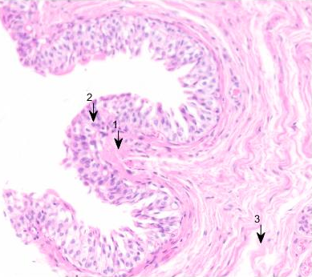 | 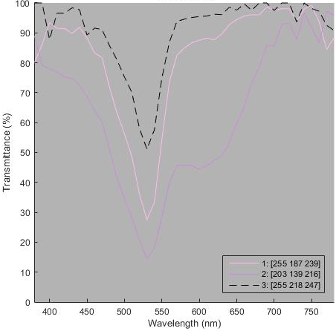
Figure 3: The multispectral imaging system measured the spectral transmittance of each pixel. Three pixels in different colors (pink, purple, and light pink) in the image on the left were chosen as examples. Their corresponding spectral transmittance curves are shown on the right.

Workflow
The workflow of this work is illustrated in Figure 4. For each ROI on the tissue slide (box 1), 41 images were acquired with wavelengths in the visible band at 380, 390,... , 780 nm (box 2). Two more images were acquired with a blank area (box 3) and an opaque area (box 4) for determining the white reference (100% transmittance) and black reference (0% transmittance), respectively. Based on the 43 images, the spectral transmittance for each pixel was calculated by linear interpolation (box 5). The spectrum of the CIE standard illuminant D65 (box 6) was then multiplied by the spectral transmittance to obtain the spectral power distribution (SPD, box 7), which simulated the optical stimuli when the tissue slide was illuminated by a hypothetical CIE D65 standard light source. The spectral power distribution, a physical measure, was converted to the CIEXYZ tristimulus (box 9), a colorimetric measure, with the standard formulas [XXX]. The CIEXYZ tristimuli of the tissue and CIE D65 (box 8) were combined to calculate the CIELAB values (box 10), which is a model that estimates how the human vision perceives the color when adapted to the reference white. CIELAB is a device-independent color space and not restricted by the color gamut of the imaging devices. The CIELAB data was used as the color truth in this study.
The rest of the dataflow determines whether a pixel can be reproduced by the sRGB color space. The CIELAB value was converted into sRGB or any device-dependent RGB color space (box 11) based on the specifications. If any of the RGB values overflew (greater than one) or underflew (less than zero), the pixel was classified as out-of-gamut (box 12). The in-gamut and out-of-gamut pixels were recorded to generate statistical results. Finally, the two sets of pixels were fused as a single image for visualization. Two types of fusing methods were used to visualize the out-of-gamut pixels. The first method truncated the out-of-gamut pixels based on the chosen color space to simulate the images obtained by a real WSI device as shown in Figure 2. The second method re-colored the out-of-gamut pixels to show the same images in Figure 6. The overflow pixels are in blue and the underflow ones, if any, in green.

Tissue
Slide¹
Spectral Trans-mittance⁵
SPD⁷
CIE
LAB¹⁰
CIE
D65⁶
In-gamut
Frame
Tissue²
Frame
Black⁴
Frame
White³
Multispectral
Imaging Systemª
CIE
XYZ⁸
CIE
XYZ⁹
sRGB¹¹
~sRGB¹²
Out-of-gamut
Fused
Image¹³
Clip or
re-color
Figure 4: Workflow of the multispectral imaging system obtaining the color truth followed by determining the in-gamut and out-of-gamut pixels for the sRGB color space.

Color Space Conversion
Three color spaces--sRGB, Adobe RGB, and ROMM RGB--were tested in this study. The same workflow was used except for the color space conversion conducted in boxes 10, 11, and 12 in Figure 4. The three color spaces belong to the group of RGB color spaces that are designed for color imaging devices such as displays and cameras with three channels or subpixels. Each RGB color space is defined by providing the primary colors and the gamma curve in the standard CIEXYZ color space. The primary colors determine the two-dimensional chromaticity characteristics and the gamma curve determines the one-dimensional luminance characteristics. To be precise, these RGB color spaces are different coordinate systems for the same CIEXYZ color space. Thus, when choosing an RGB color space, it can be considered as choosing the encoding method for colors in an absolute space. All RGB color spaces have the additivity property, so the white point is the sum of the three primary colors.

From CIEXYZ to sRGB
The sRGB (standard red, green, and blue) color space was proposed in 1994 and adopted as the IEC standard.

XYZ_{R} = (0.4125, 0.2127, 0.0193)
XYZ_{G} = (0.3576, 0.7152, 0.1192)
XYZ_{B}= (0.1804, 0.0722, 0.9503)
$\left[\begin{matrix}R' \\ G' \\ B'\end{matrix}\right]=\left[\begin{matrix}3.2406 & -1.5372 & -0.4986 \\ -0.9689 & 1.8758 & 0.0415 \\ 0.0557 & -0.2040 & 1.0570\end{matrix}\right]\left[\begin{matrix}X \\ Y \\ Z\end{matrix}\right]$ (1)
$R=\left\{\begin{matrix}12.92 R', & R≤0.0031308 \\ & \\ (1+0.055){R'}^{1/2.4}, & R>0.0031308\end{matrix}\right.$ (2)
G and B can be calculated similarly.

From CIEXYZ to Adobe RGB
The Adobe RGB has a larger color gamut than that of the sRGB.
XYZ_{R} = (0.57667, 0.18556, 0.18823)
XYZ_{G} = (0.29734, 0.62736, 0.07529)
XYZ_{B} = (0.02703, 0.07069, 0.99134)
$\left[\begin{matrix}R' \\ G' \\ B'\end{matrix}\right]=\left[\begin{matrix}1.96253 & -0.61068 & -0.34137 \\ -0.97876 & 1.91615 & 0.03342 \\ 0.02869 & -0.14067 & 1.34926\end{matrix}\right]\left[\begin{matrix}X \\ Y \\ Z\end{matrix}\right]$ (3)
$R={R'}^{1/2.19921875}$ (4)
G and B can be calculated similarly.
Notice that the Adobe RGB color gamut larger in the sense that the chromaticity is larger and the intensity is greater.

From CIEXYZ to ROMM RGB
The ROMM RGB has a larger color gamut than that of the Adobe RGB.
XYZ_{R} = (0.7976, 0.2880, 0)
XYZ_{G} = (0.1352, 0.7119, 0)
XYZ_{B} = (0.0313, 0.0001, 0.8249)
$\left[\begin{matrix}R' \\ G' \\ B'\end{matrix}\right]=\left[\begin{matrix}1.3460 & -0.2556 & -0.0511 \\ -0.5446 & 1.5082 & 0.0205 \\ 0.0 & 0.0 & 1.2123\end{matrix}\right]\left[\begin{matrix}X \\ Y \\ Z\end{matrix}\right]$ (5)
$R=\left\{\begin{matrix}16 R', & R<0.001953 \\ & \\ {R'}^{1/1.8}, & R≥0.001953\end{matrix}\right.$ (6)
G and B can be calculated similarly.

Results
The CIELAB values of each pixel of the eight samples were obtained (Figure 4, box 10). Error! Reference source not found. shows the distributions of the colors in the CIELAB color space for each sample. Ten thousand random pixels of each ROI were selected to generate the histogram in the CIELAB space. The CIELAB space is represented by the (a*, b*, L*) coordinates. The (a*, b*, L*) values of all pixels were binned in every one L*, every one a*, and every one b*. Each non-zero bin was represented as a dot painted with the corresponding color. The size of each dot non-linearly represents the count for the bin.
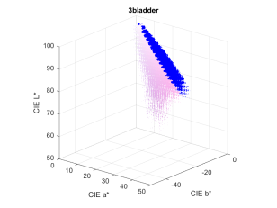  (a) Bladder | 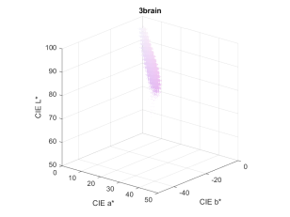  (b) Brain
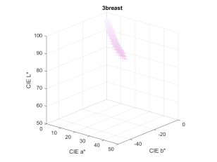  (c) Breast | 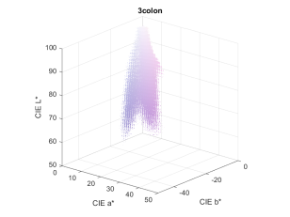  (d) Colon
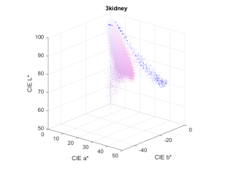  (e) Kidney | 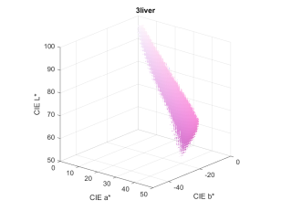  (f) Liver
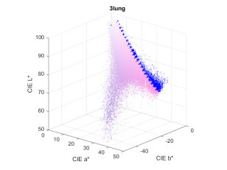  (g) Lung | 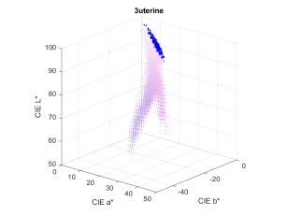  (h) Uterus
Figure 5: Color distributions in the CIELAB color space. (a) bladder, (b) brain, (c) breast, (d) colon, (e) kidney, (f) liver, (g) lung, and (h) uterus.

Most of the eight samples have four obvious groups of shades -- white, eosin-stained pink, hematoxylin-stained purple and red blood cells. The blank areas in each ROI are white shades and binned near (0,0,100), the top of each distribution. The white shades are followed by the eosin-stained pink shades which extend from (0,0,100) toward positive a* (increasing red) and negative b* (increasing blue). The eosin-stained pink shades gradually transition into the hematoxylin-stained purple, which have lower L* (darker), lower b* (increasing blue), and slightly lower a* values (increasing green). For instance, sample d has a large cluster of purple shades alongside the pink shades. Some samples (e.g., e and g) have sparse red blood cells, which have larger a* (increasing red) values outside the cluster of the white, pink and purple shades.

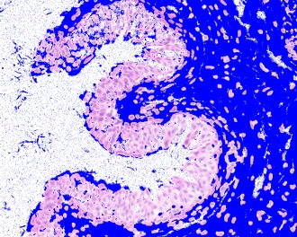(a) Bladder | 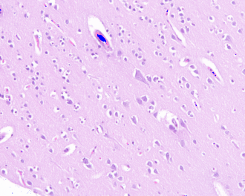  (b) Brain | 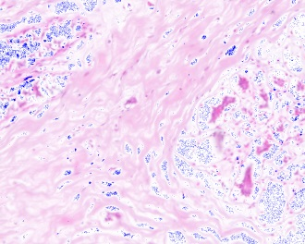  (c) Breast | 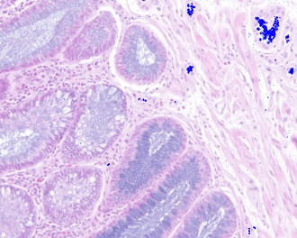  (d) Colon
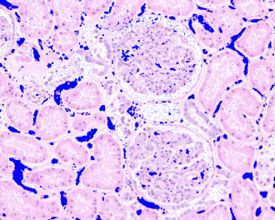  (e) Kidney | 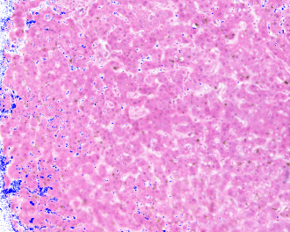  (f) Liver | 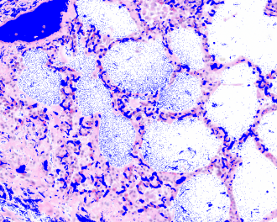  (g) Lung | 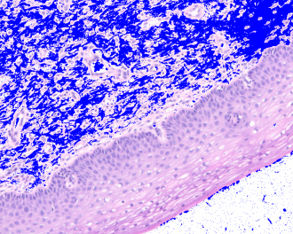  (h) Uterus
Figure 6: Pixels cannot be shown in the color gamut of the sRGB color space are re-colored in blue. (a) bladder, (b) brain, (c) breast, (d) colon, (e) kidney, (f) liver, (g) lung, and (h) uterus.

The pixels that are out of the sRGB color gamut are re-colored in Figure 6. A large area of the bladder sample was outside the color gamut of sRGB followed by uterus, lung, and kidney. The out-of-gamut pixels were mainly eosin-stained pink shades that have very high L* values (bright pink shades). The percentage of out-of-gamut pixel counts are listed in Table 1.

For the Adobe RGB color space, only the bladder sample had 0.03% of pixels were out of gamut. The other seven samples had none out-of-gamut pixels.
For the ROMM RGB color space, none of the eight samples had any out-of-gamut pixels.

Table 1: The out-of-gamut percentage in the color spaces.
 | sRGB | Adobe  RGB | ROMM  RGB
Bladder | 34.94% | 0.03% | 0.00%
Brain | 0.10% | 0.00% | 0.00%
Breast | 0.08% | 0.00% | 0.00%
Colon | 0.48% | 0.00% | 0.00%
Kidney | 5.38% | 0.00% | 0.00%
Liver | 0.81% | 0.00% | 0.00%
Lung | 10.12% | 0.00% | 0.00%
Uterus | 16.62% | 0.00% | 0.00%

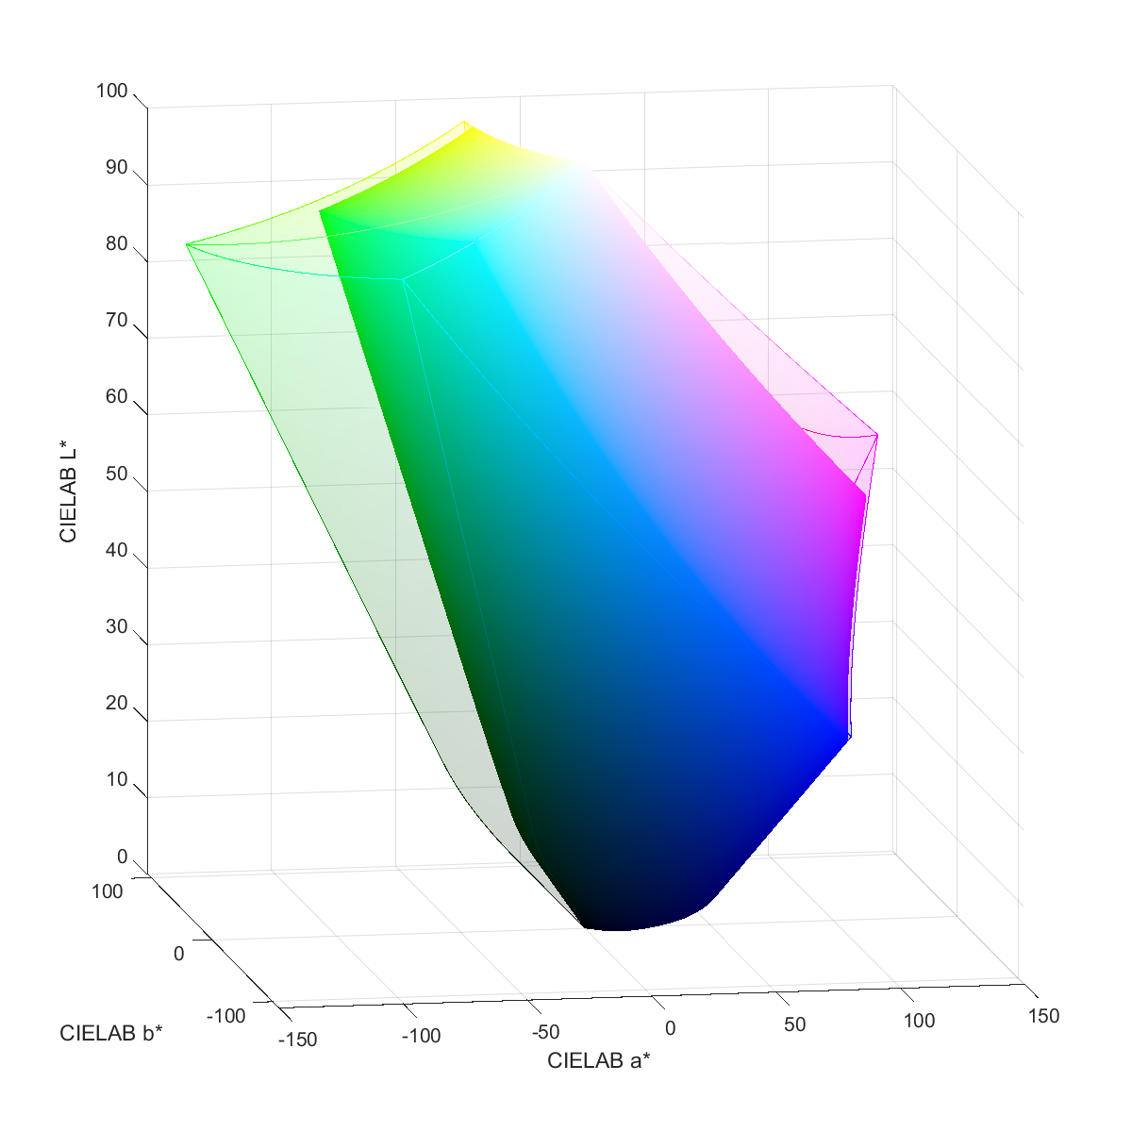
Figure 7: Comparison between the sRGB (solid volume) and Adobe RGB (transparent volume) in the CIELAB color space. Most of the out-of-sRGB-gamut bright pink shades are in the region XZZXX.

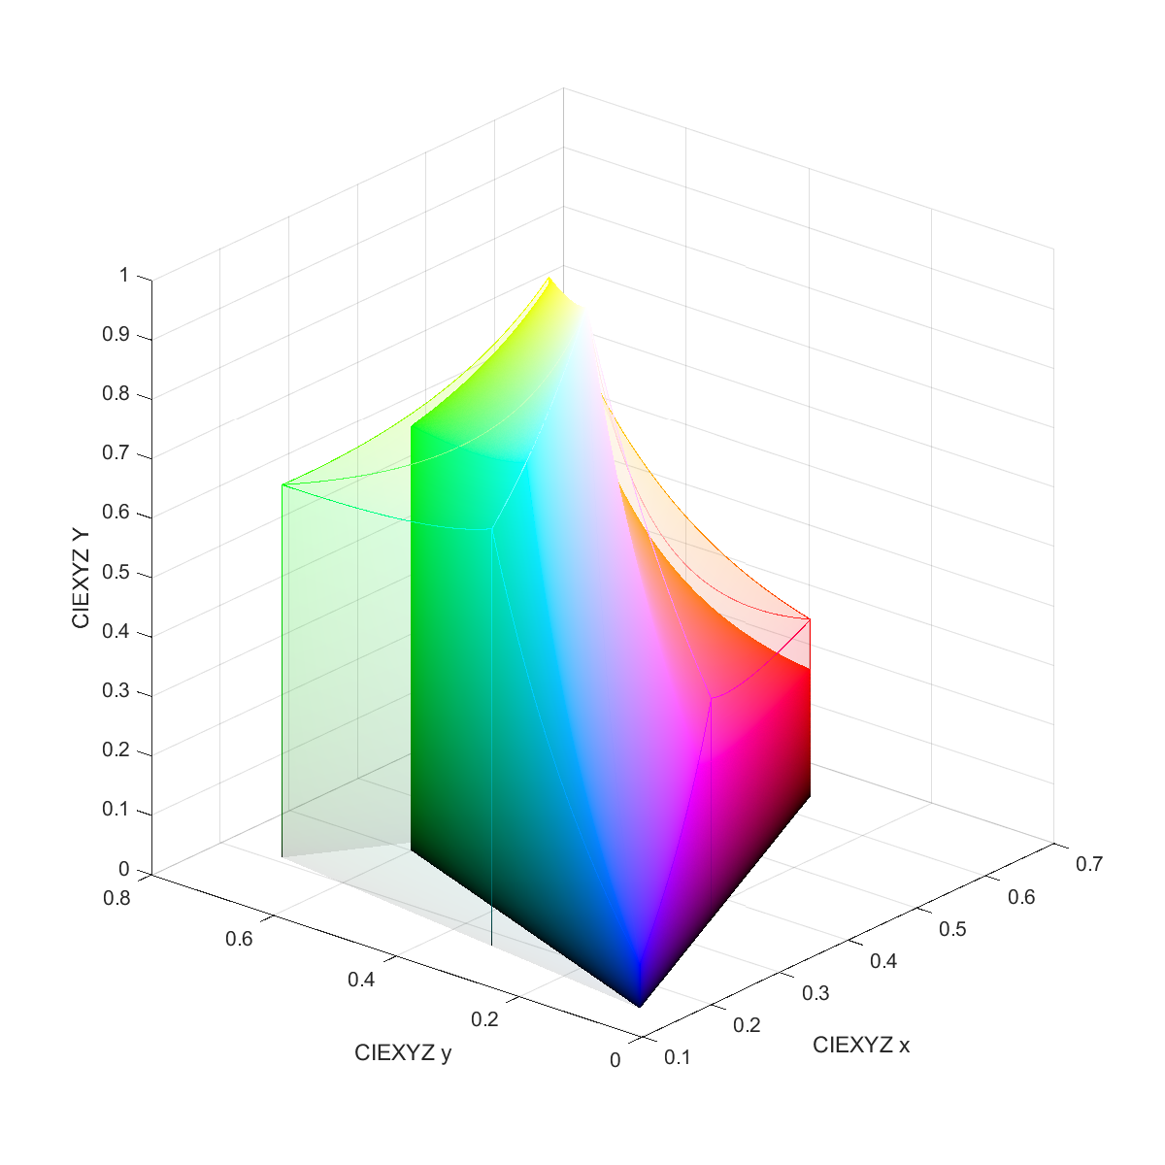
Figure 8: Comparing sRGB (solid volume) with Adobe RGB (transparent) in CIE (x,y,Y), where (x,y) represents the chromaticity and Y the luminance. The red primary of Adobe RGB (pointed by the arrow) has a higher intensity that envelops more bright pink shades in its color gamut.

Discussion
The implication of the findings is the limitation imposed by a color space to the imaging chain. For example, if a WSI scanner uses sRGB to store the scanned image, then some color information is bound to be lost once the image is saved as a file. As another example, if an sRGB display is used to review H&E-stained slides, some eosin-stained pink shades may not be properly reproduced compared with a light microscope.
According to the experiment results, the legacy sRGB color space does not have sufficient color gamut for many of the eight samples. The newer Adobe RGB color space includes most colors present in the eight samples. The ultra-wide color gamut provided by the ROMM color space undoubtedly can include all eight samples. However, in practice, imaging devices are driven by integer pixel data. To preserve the same resolution in the color space, widening the color gamut demands a wider range of the imaging data, meaning that the bit-depth needs to be increased, which was not investigated in this study.
In this work, the three color spaces represent one imaging encoding method, which is using a device-dependent color space to encode the absolute color. Another method is using a color profile such as the standard ICC color profile to record the mapping between the digital data and the absolute color.
Future work: more stains and tissue types

Limitations
The proposed method evaluates only one frame of the video stream, so the test result may not wholly reflect the real-world performance of the endoscopy device if the device does not perform deterministically.
dE how to estimate errors: clipped colors, absolute error not important; relative differences between the signals

Conclusions

Acknowledgements
The author thanks Jocelyn Liu for identifying the pathological features and collecting the image data. The mention of commercial products herein is not to be construed as either an actual or implied endorsement of such products by the Department of Health and Human Services.

Extra
Compared with a light microscope, a WSI system is limited by its capabilities of acquiring and reproducing different shades of colors, i.e., the color gamut. The color gamut is determined by not only the optical characteristics of the system, but also how the image data is encoded in a color space. The designated color space is important because it substantiates the meaning of the image data exchanged between imaging devices and establishes the mapping from the digital pixel data to the optical properties. Although new color spaces have been proposed to accommodate wider color gamut in the past years, most existing WSI systems are still using the legacy color space with limited color gamut. In this work, an experiment was conducted to investigate whether the color gamut of commonly used color spaces covers the colors present in hematoxylin and eosin (H&E) stained histological tissue samples.

Eight H&E-stained tissue samples were measured with a multispectral imaging system to obtain the true colors on the pixel level. The measured color of each pixel was converted into the standard CIELAB color space to check whether it is within the color gamut of the color space. Three color spaces were tested -- sRGB, Adobe RGB, and ROMM RGB. The percentage of out-of-color-gamut pixels was reported for each color space. The results show that all the eight images have some pixels outside the sRGB color gamut. In the worse-case scenario, the bladder sample, about 35% of the image exceeds the sRGB color gamut. In the Adobe RGB color space, only the bladder image cannot be completely contained (99.97%). The color gamut of the ROMM RGB color space is wide enough to cover all eight images.

Conflicts of Interest
There are no conflicts of interest. The mention of commercial products herein is not to be construed as either an actual or implied endorsement of such products by the Department of Health and Human Services.

References

[7] Berns, Roy S. Billmeyer and Saltzman's principles of color technology. New York: Wiley, 2000.
[8] Ohta, Noboru, and Alan Robertson. Colorimetry: fundamentals and applications. John Wiley & Sons, 2006.
[sRGB]
[Adobe RGB] https://en.wikipedia.org/wiki/Adobe_RGB_color_space
[ROMM] http://www.color.org/chardata/rgb/ROMMRGB.pdf
[1] Saleheen, Firdous, Badano, Aldo, and Cheng, Wei-Chung. "Evaluating color performance of whole-slide imaging devices by multispectral-imaging of biological tissues." Medical Imaging 2017: Digital Pathology. Vol. 10140. International Society for Optics and Photonics, 2017.
[2] FDA, “Guidance for industry and food and drug administration staff: Technical performance assessment of digital pathology whole slide imaging devices. 2016. http://www.fda.gov/downloa- ds/medicaldevices/deviceregulationandguidance/guidancedocuments/ucm435355.pdf,” Guidance for industry and Food and Drug Administration Staff: Technical Performance Assessment of Digital Pathology Whole Slide Imaging Devices. (2016).
[3] Kohonen, Oili, Parkkinen, Jussi, Jaaskelainen, Timo. “Databases for spectral color science.”
[4] Badano, A., Revie, C., Casertano, A., Cheng, W.-C., Green, P., Kimpe, T., Krupinski, E., Sisson, C., Skrovseth, S., Treanor, D., et al., “Consistency and standardization of color in medical imaging: a consensus report,” Joural of digital imaging 28(1), 41-52 (2015).
[5] Cheng, W.-C., Keay, T., O’Flaherty, N., Wang, J., Ivansky, A., Gavrielides, M. A., Gallas, B. D., and Badano, A., “Assessing color reproducibility of whole-slide imaging scanners,” in [SPIE Medical Imaging], 86760O-86760), International Society for Optics and Photonics (2013).
[6] Yagi, Y., “Color standardization and optimization in whole slide imaging,” Diagnostic pathology 6(1), 1 (2011).
[7] Shrestha, P. and Hulsken, B., “Color accuracy and reproducibility in whole slide imaging scanners,” Journal of Medical Imaging 1(2), 027501-027501 (2014).
[8] Revie, W. C., Shires, M., Jackson, P., Brettle, D., Cochrane, R., and Treanor, D., “Color management in digital pathology,” Analytical cellular pathology (Amsterdam) 2014(2014).
[9] Parwani, A. V., Hassell, L., Glassy, E., Pantanowitz, L., et al., “regulatory barrier surrounding the use of whole slide imaging in the united states of america,” Journal of pathology informatics 5(1), 38 (2014)
[10] Sharam G, Wu WC, Dalal EN. “The CIEDE2000 color-difference formula: Implementation notes, supplementary test data, and mathematical observations.” Color Res Appl. 2005;30(1):21-30.
[] DICOM book chapter
Herrmann, Markus D., et al. "Implementing the DICOM standard for digital pathology." Journal of pathology informatics 9 (2018).
Norgan, Andrew P., et al. "Comparison of a Medical-Grade Monitor vs Commercial Off-the-Shelf Display for Mitotic Figure Enumeration and Small Object (Helicobacter pylori) Detection." American journal of clinical pathology 149.2 (2018): 181-185.
Krupinski, Elizabeth A. "Medical grade vs off-the-shelf color displays: influence on observer performance and visual search." Journal of digital imaging 22.4 (2009): 363-368.
Salazar, Antonio J., et al. "DICOM gray-scale standard display function: clinical diagnostic accuracy of chest radiography in medical-grade gray-scale and consumer-grade color displays." American Journal of Roentgenology 202.6 (2014): 1272-1280.
Pinto dos Santos, Daniel Pinto, et al. "Comparison of medical-grade and calibrated consumer-grade displays for diagnosis of subtle bone fissures." European radiology 27.12 (2017): 5049-5055.
Kimpe, Tom, and Tom Tuytschaever. "Increasing the number of gray shades in medical display systems—how much is enough?." Journal of digital imaging 20.4 (2007): 422-432.

